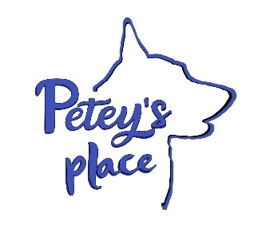
CUSTOMER AGREEMENT BOARDING & DAYCARE

Customer's Name: ___________________________________________________________________________
Address: ______________________________________________________________________________________

Email Address: ______________________________________________________________________________
Phone Number: _____________________________________________________________________________
Pet's Name, Age and Breed: ____________________________________________________________________________________________________________________________________________________________________________________________________________________________________
Emergency Contact Person/s and Phone Number:
_________________________________________________________________________________________________

Feeding Instructions- Once a day or Twice a Day? How much each feeding (Owner provides food):
________________________________________________________________________________________________________________________________________________________________________
Special Instructions for Medicine, if applicable:
____________________________________________________________________________________
___________________________________________________________ __________________________
Does your pet have any behavior or aggression problems? Have they been around other dogs?

1. AGRESSION- This statement is your agreement your dog has not bitten, or exhibited other aggressive behavior, towards any person or animal. ***Signs of uncontrolled aggression will result in seclusion and early pickup of your dog. Dog owner will be liable for any injury to other dogs or persons.
(initial)

2. DAMAGE TO PROPERTY -Unless otherwise disclosed to Petey’s Place Dog Boarding, my dog is housebroken and my is not prone to chewing, scratching, digging or other destructive behavior; dog owner is liable for destruction totaling more than $50 worth. ***Additional charges will be applied to the total boarding fee if there is damage to property of Petey’s Place boarding facility due to pet misbehavior. All necessary precautions will be made to ensure safety of your pet and others. (initial)

3. VACCINES- The pet is current on all required vaccinations as is required by Petey’s Place. Owner agrees to provide documents confirming such vaccinations. Vaccinations must be within one year before entry at the facility. Vaccinations are as follows;
Rabies, Bordetella and Distemper/ Parvo _______ (initial)

4. SPAY/ NEUTER- My dog has been spayed or neutered as required by Petey’s Place prior to any boarding visit unless otherwise disclosed to Katrina Will at Petey’s Place for her possible exception. _______ (initial)

6. SICKNESS-The pet is free of fleas, ticks, worms and other insects and parasites. The pet has no current illness or injury, except as has been disclosed to Petey’s Place. _______ (initial)

7. PHOTOS AND VIDEO RELEASE. Dog owner agrees to allow Petey’s Place to use his or her pet’s name and any images or likeness of his or her pet taken while the pet is at the facility, in any form or format, for use, at any time, in any media, marketing, advertising, illustration, trade or promotional materials. _______ (initial)

8. ABANDONED PETS. Dog owner understands and agrees that if his or her pet is not picked up within seven (7) calendar days after the scheduled pick up date, the pet shall be deemed to be abandoned and additional boarding charges shall apply, and in such event, Petey’s Place shall gain legal custody and ownership of the pet and retain the right to keep the pet, or place the pet in a shelter or with animal control, or place the pet in a new home with a new owner, with no recourse by Dog Owner against Kat’s Kritter Service LLC, Petey’s Place or Katrina Will. _______ (initial)

Dog Owner has read and fully understands the terms of this agreement. Including the releases, waivers of liability, acceptance of risk and indemnity provisions and understands that the dog owner has given up substantial rights by signing it and has signed it freely and voluntarily without any inducement, assurance or guarantee and intends it to be a complete and unconditional release of all liability to the greatest extend permitted by the law. Dog owner agrees that it is intended that all terms of this agreement control despite any statute or law that would otherwise protect dog owner or his or her dog. Dog owner is advised to seek legal counsel if Dog owner is unsure of the effects of this foregoing agreement. Accepted and Agreed to by:
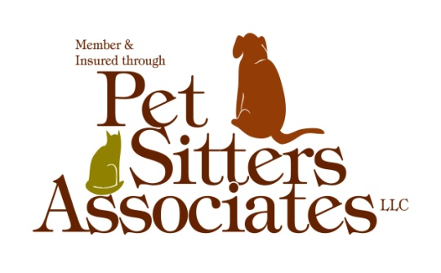

_________________________________________ ___________________________
Pet Owner's Signature Date

PAYMENT is due at the time of pick up for all boarding visits.

